ME331 Advanced Thermo

September 19, 2018

Min Joon So

1. **Draw conclusions from your results.**

Efficiency

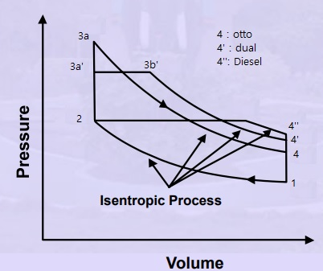

1. **Formulate an executive summary intended for your company's engineering management team that describes your research; develop logical arguments supporting your conclusions regarding your recommendations on how your company should be designing engines with regard to these 3 parameters.**

Three parameter

1. **Perform background research (a brief literature review) that reflects your understanding of current trends in piston-engine design.**

Find online